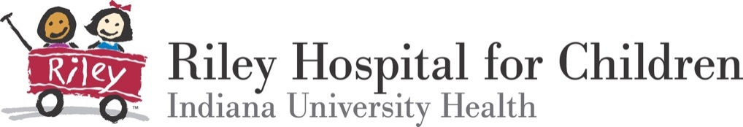

Lauren Servos, MT-BC
Manager, Creative Arts Therapies
Internship Director, Riley Cheer Guild Music Therapy Program
Riley Hospital for Children at Indiana University Health
705 Riley Hospital Drive, Room 4530
Indianapolis, IN 46202
lservos@iuhealth.org
463.280.0979

Application for Music Therapy Internship

Personal/Contact Information

Today’s Date: Click here to enter a date.

Internship start date you prefer (check one): ☐ Fall ☐ Winter ☐ Either Year: Click here to enter text.
Name of your academic institution: Click here to enter text.

On what date will you or did you complete your academic training? Click here to enter a date.

Prospective Intern Name: Click here to enter text.
Telephone #: Click here to enter text. Email: Click here to enter text.
Mailing Address: Click here to enter text.
Academic Director Name: Click here to enter text.
Telephone #: Click here to enter text. Email: Click here to enter text.

Administrative Requirements

Once an offer for internship is made by the Riley Cheer Guild Music Therapy team, a member of the Health Sciences Education department at Indiana University Health will contact the prospective intern’s school to establish a legal affiliation agreement. The affiliation agreement will include specific information about the following items, which may not be provided by IU Health:

- Medical Insurance
- Criminal Background check
- MMR Vaccines
- Rubella AB Titer
- Rubeola Measles AB Titer
- Mumps AB Titer
- Diphtheria, Tetanus, Pertussis Vaccine
- Annual Influenza Vaccine (must be for the current flu season)
- Hepatitis Vaccine or Titer (or declination form)
- Varicella Vaccine or Titer
- Annual TB Test
- Drug Screen
- CPR Certification
- N95 Fit Testing

Required Attachments

- One letter of eligibility/verification from your academic advisor
- Two letters of recommendation
  - Include at least one from a clinical supervisor describing your clinical experiences and skills in music therapy as well as your musicianship.
  - NOTE: Letter of eligibility and letters of recommendation should be sent separately by the person completing the letter/form and may be sent via email or US post.
- Resume
  - Include specific information related to your practicum/clinical experiences. (e.g., types of clients, sessions, facility, treatment goals, responsibilities, and number of direct therapy contact hours)
- Copy of transcripts from all college/university coursework
- Original narrative essay describing why you are pursuing music therapy as a career. Include the following information:
  - Reasons for choosing this particular internship experience and what your expectations are from both the internship director and this internship program.
  - Describe personal and professional strengths you will bring to this experience.
  - Articulate your personal style/philosophy of interaction with children/adolescents. Elaborate with any previous experiences you have had with this population in the clinical and/or non-clinical setting.
  - Communicate the primary areas you hope to cultivate during your six months of clinical training.
  - Provide the link to your YouTube application video (described below) at the end of the essay.
- Application video uploaded as an unlisted YouTube video (5 minutes or less) that includes the following:
  - Introduce yourself and briefly describe who you are.
  - Perform a one song you have used in a clinical setting and describe how it was used.
  - Perform sections of two additional songs you think would be appropriate for the pediatric medical setting.
  - The songs performed should include demonstrations of your vocal and guitar abilities, as well as one other instrument of your choice.

References

One letter of verification from your academic advisor stating eligibility and two letters of recommendation required

1. Academic Advisor Name: Click here to enter text.

Phone Number: Click here to enter text. Email: Click here to enter text.

2. Name: Click here to enter text. Relationship: Click here to enter text.

Phone Number: Click here to enter text. Email: Click here to enter text.

3. Name: Click here to enter text. Relationship: Click here to enter text.

Phone Number: Click here to enter text. Email: Click here to enter text.

Prospective Intern Signature: Click here to enter text. Date: Click here to enter a date.

*Submitting application via email implies electronic signature by the applicant*

Once all application materials and attachments are received, the internship director will make contact regarding the scheduling of onsite interview (preferred) or video conference interview for individuals who are unable to travel to site for interview.

This application, essay, resume, letters of recommendation, transcripts should be emailed or mailed to:

Lauren Servos, MT-BC
Manager, Creative Arts Therapies
Internship Director, Riley Cheer Guild Music Therapy Program
Riley Hospital for Children at Indiana University Health
705 Riley Hospital Drive, Room 4530
Indianapolis, IN 46202
lservos@iuhealth.org
463.280.0979

